Author
BABS THE ANALYST
Northwind Sales Performance Analysis Report

CONTENT
- Introduction
- Project Overview
- Problem Statement
- Data Overview
- Tools Used
- Data Cleaning and Transformation
- Observations and Insight
- Recommendation
- Conclusion

Northwind Sales Performance Analysis Report
- Introduction
The Northwind Sales Performance Analysis project aims to evaluate the sales, customer, and product performance of the Northwind company using its transactional dataset. The Northwind dataset, widely used in analytics and business intelligence learning, simulates real-world trading activities between suppliers, employees, customers, and products across multiple countries.
This report provides in-depth insights into business performance metrics such as total revenue, orders, customer distribution, and product profitability. The analysis was designed to help management make data-driven decisions in areas such as marketing strategy, sales optimization, and product management.

- Project Overview
The Northwind Sales Performance Dashboard was developed to serve as a comprehensive tool for monitoring and evaluating the company’s performance across three key dimensions:
  - Sales & Revenue Overview: Evaluates overall sales trends, revenue growth, employee performance, and geographical contribution.
  - Customer & Market Insight: Analyzes customer behavior, order distribution, and top-performing clients.
  - Product Performance: Reviews active and discontinued products, best-selling items, and revenue contribution by category. The project transforms raw transactional data into actionable business intelligence using Power BI’s visualization and DAX analytical capabilities.

- Problem Statement
The Northwind company needed a robust analytical solution to address the following business challenges: Lack of centralized reporting to monitor sales, products, and customer activities in real-time. Difficulty identifying top-performing products, employees, and customers for performance incentives and retention planning. Unclear understanding of revenue contribution by region, affecting global sales strategy. Need for data-backed decisions on product continuity (active vs discontinued products). This project was designed to build a performance dashboard that enables management to visualize key business drivers, uncover hidden patterns, and make timely, evidence-based decisions.

- Dataset Overview
The dataset contains multiple interrelated tables, including:
- Orders: Contains details about customer orders including Order ID, Employee, Customer, and Ship Country.
- Order Details: Contains product-level transaction data such as Unit Price, Quantity, and Discount.
- Product: Includes product details like Category, Supplier, and Discontinued status.
- Customers: Holds customer names, contact details, and location.
- Employees: Details about sales representatives and their territories.
- Categories: Lists product categories (Beverages, Dairy, Seafood, etc.).

- Tools Used
- Power BI: Data modeling, visualization, and dashboard design
- Power Query: Data cleaning, transformation, and pre-processing
- DAX (Data Analysis Expressions): Calculated columns, KPIs, and advanced measures
- Data Modelling: like Fact table: Orders; Dimension tables: Products, Employees, Customers, Categories

- Data Cleaning and Transformation
Data preparation was a crucial phase before insights and visualization. Below are the major cleaning and transformation steps performed:
  - Data Extraction: Imported multiple CSV files (Orders, Order Details, Products, Employees, etc.) into Power BI.
  - Data Cleaning: Removed duplicate rows and null values. Standardized data formats (especially date and currency fields). Replaced missing category and customer IDs where applicable. 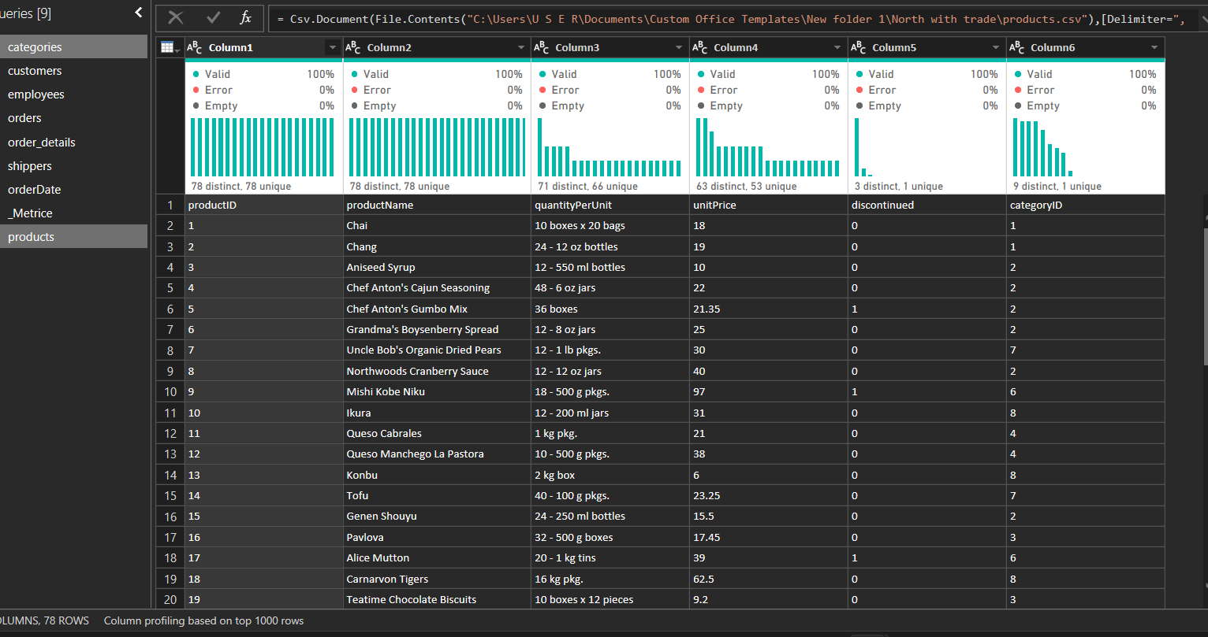
  - Data Transformation: Created new calculated columns: Total Revenue = Unit Price * Quantity * (1 - Discount). Average Revenue = Total Revenue / Total Orders
  - Merged tables using Power BI to form a relational model. Built a Star Schema model, linking the Orders fact table to dimension tables.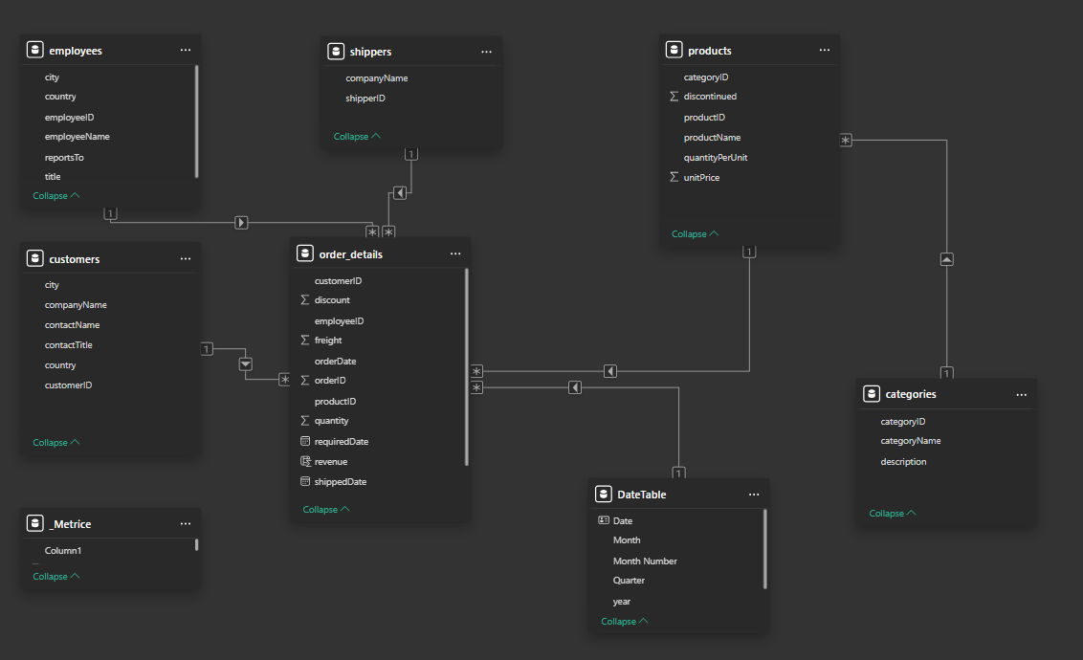

  - Validation: Verified totals and calculated KPIs using DAX measures.
These processes ensured the dataset was clean, accurate, and ready for visualization.

- Observation and Insights Analysis
- KPIs
- Total Revenue:
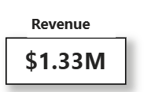
Interpretation: The dashboard revealed that Northwind generated approximately $1.33 million in total revenue from all orders. This serves as a strong indicator of the company’s overall market performance and highlights the effectiveness of its product mix and customer base in driving sales.
- Total Orders:
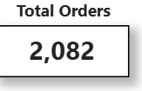
Interpretation: A total of 2,082 orders were recorded across multiple countries. This figure demonstrates a healthy sales operation and suggests consistent customer engagement throughout the analyzed period.
- Total Customers
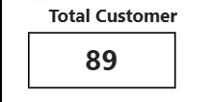
Interpretation: Northwind served 89 active customers, showcasing a diverse customer base spread across multiple regions. A wide distribution of customers reduces dependence on a few clients and provides stability in revenue flow.
- Total Product Sold
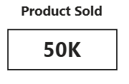
Interpretation: The total number of product units sold across all transactions. it measures product movement and demand intensity. Identifies top-selling items and assists in inventory planning.
- Average Revenue
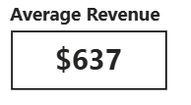
Interpretation: It indicates how much revenue each customer order generates on average. A higher AOV reflects strong cross-selling or higher-value products being purchased.

- Insights Analysis
- Sales & Revenue Overview:
Monthly Revenue Trend
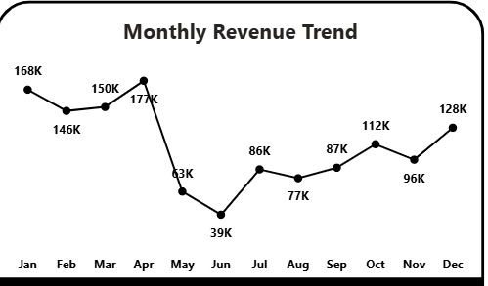
Interpretation: The Monthly Revenue Trend visualization shows fluctuations in sales performance across different months of the year.
- Revenue peaked in April, indicating a seasonal surge in customer purchases during the second quarter.
- June recorded the lowest revenue, suggesting a potential slowdown after the early-year sales push. This trend analysis helps management plan promotions, inventory, and staffing around high-demand periods to maintain consistent sales performance throughout the year.

- Revenue by Employee
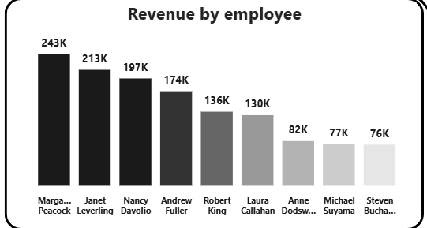
Interpretation: Margaret Peacock, Janet Leverling, and Nancy Davolio emerged as the top performers, collectively contributing the majority of total company revenue. Other employees showed moderate performance, suggesting an opportunity to analyze what makes the top employees successful such as client engagement style or product focus and replicate it across the team. This insight supports employee evaluation, target setting, and performance-based incentive programs.

Revenue by Category
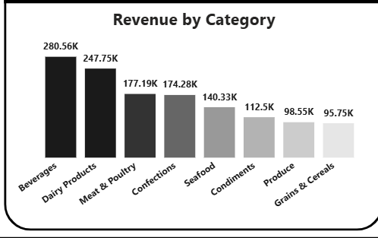
Interpretation: Beverages led overall sales volume, likely due to their universal demand and broad customer base. Dairy Products followed closely, driven by frequent reorders and product dependency. Lower-performing categories, like Grains/Cereals and Condiments, could benefit from marketing initiatives or bundling strategies. This insight enables strategic product prioritization and inventory optimization.

Revenue by Country
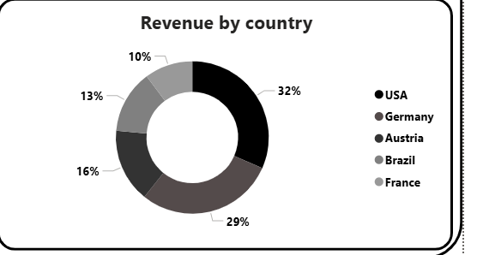
Interpretation: The Revenue by Country visualization highlighted that the United States (32%) and Germany (29%) contributed the largest portions of total sales. Other notable markets included Austria, France, and Brazil. This geographic distribution emphasizes Northwind’s strong presence in North America and Europe, with potential for expansion into underperforming regions. By investing in logistics, promotions, and local partnerships, Northwind can diversify its revenue base and reduce dependence on a few key markets.

- Customer & Market Insight
Customer & Market Insight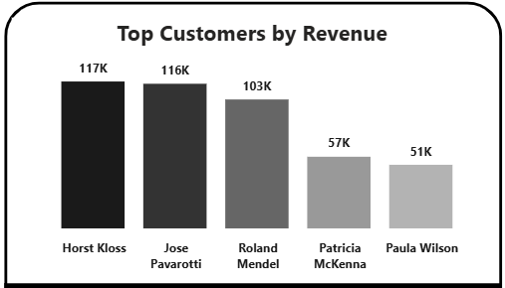
Interpretation: The Top Customers by Revenue chart identified Ernst Handel, Save-a-Lot Markets, and Quick-Stop as the most valuable clients. These customers consistently place large and frequent orders, generating a significant share of total revenue. Focusing on customer retention, personalized offers, and priority service for these clients can sustain and increase long-term profitability. Additionally, identifying medium-tier customers with growth potential supports customer development strategies.

Orders by Country
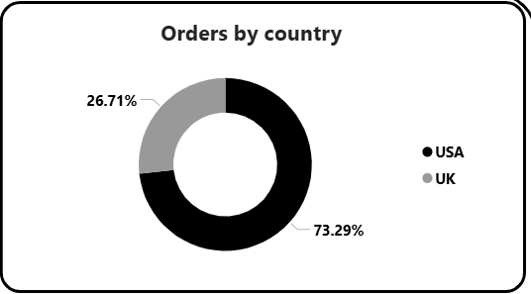
Interpretation: The Orders by Country visualization complements the revenue map by showing which countries generate the highest order volumes. While the USA and Germany led both in total revenue and number of orders, some regions like France and Brazil showed moderate order activity but smaller revenue implying smaller average order values.
This distinction helps Northwind tailor country-specific pricing and product bundling strategies to boost order size and profitability.

Customer Orders by Product
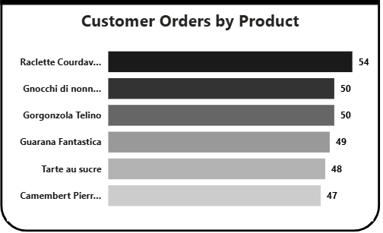
Interpretation: This visualization analyzed which products individual customers purchased most frequently. It revealed clear purchasing patterns for example, some customers consistently buy the same high-demand items, such as Chai, Chang, and Aniseed Syrup. Understanding these habits enables personalized marketing campaigns, better demand forecasting, and efficient inventory planning to avoid stockouts or overproduction.

Most Ordered Product Category by Order
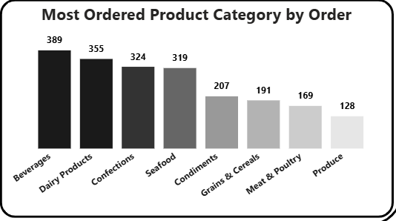
Interpretation: The analysis showed that Beverages and Confections categories recorded the highest number of orders, indicating high product rotation and repeat purchases. These categories attract frequent customer demand, making them essential for maintaining steady sales momentum. This insight supports supply chain planning, ensuring that popular items remain consistently available to avoid lost sales opportunities.

- Product Performance:
Active and Discontinued Products
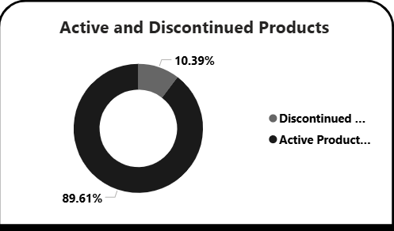
Interpretation: The Product Status chart revealed a mix of active and discontinued products in the catalog.
- Active products continue to generate the bulk of revenue.
- Discontinued products, while still recorded historically, highlight the importance of maintaining an updated product line aligned with market trends.
Analyzing performance before discontinuation can reveal whether the removal was due to low demand, high costs, or supply challenges, providing lessons for future product management decisions.

Top 5 Products by Quantity Sold
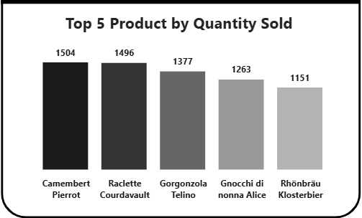
Interpretation: The Top 5 Products by Quantity Sold analysis identified high-volume items like Chai, Chang, Aniseed Syrup, Chef Anton’s Cajun Seasoning, and Tofu as the company’s most frequently sold products. These items form the backbone of Northwind’s sales volume and reflect strong customer loyalty. Focusing marketing campaigns on these popular items can help sustain high sales momentum and attract new customers through proven demand products.

Customers by Product Category
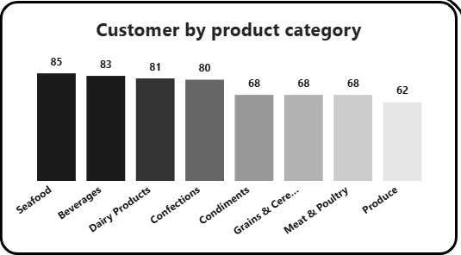
Interpretation: This insight segmented customers based on their purchasing preferences across different product categories. It showed that certain customers specialize in specific categories — for example, some buy mainly Beverages, while others focus on Dairy or Confections. This segmentation helps in targeted marketing and cross-selling opportunities, allowing Northwind to offer related or complementary products to the right customer group.

Top 5 Products by Revenue
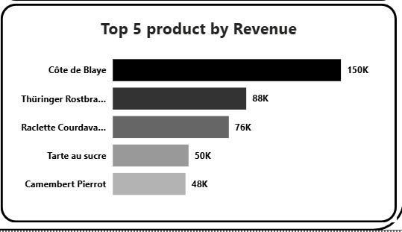
Interpretation: Finally, the Top 5 Products by Revenue visualization identified the products that contributed the most income, not just in quantity but also in sales value. Items such as Côte de Blaye, Thüringer Rostbratwurst, Raclette Courdavault, and Mishi Kobe Niku generated the highest total revenue due to their premium pricing and strong demand. These products, although possibly lower in quantity sold, provide higher profit margins highlighting the importance of maintaining a balanced portfolio between high-volume and high-value products.

- Recommendations
Based on the dashboard insights and sales performance analysis, the following strategic recommendations are proposed to help Northwind strengthen revenue growth, improve operational efficiency, and enhance customer relationships:
- Strengthen High-Performing Product Categories
- Focus marketing and inventory strategies on Beverages and Dairy Products, which consistently generate the highest sales and revenue.
- Introduce cross-selling promotions (e.g., bundle Beverages with Confections) to increase the average order value.
- Maintain adequate stock levels to meet high demand during peak months like April.
- Expand Market Reach in Underperforming Countries
- While the USA and Germany dominate sales, emerging markets such as France, Brazil, and Austria show untapped potential.
- Develop localized marketing campaigns and build partnerships with regional distributors to increase market penetration.
- Tailor product offerings based on local preferences and pricing sensitivity to boost order frequency.
- Recognize and Replicate Employee Success
- Margaret Peacock, Janet Leverling, and Nancy Davolio consistently outperform peers.
- Conduct internal knowledge-sharing sessions to identify best practices in sales approach and client engagement.
- Introduce performance-based incentives and targeted training to uplift overall employee productivity.
- Focus on High-Value Customers
- Prioritize retention strategies for key customers like Ernst Handel, Save-a-Lot Markets, and Quick-Stop, who contribute significantly to total revenue.
- Implement customer loyalty programs and personalized offers to increase repeat purchases.
- Use customer segmentation to identify mid-tier customers with potential for long-term growth.
- Manage Seasonal Fluctuations Proactively
- Align marketing campaigns and discount strategies around high-demand months (e.g., Q2 peaks).
- Use predictive analytics to forecast demand and optimize inventory before low-sales periods (e.g., June).
- Offer seasonal product bundles to stabilize sales during slow months.

- Optimize Product Portfolio
- Retain top-selling products that drive volume and premium products that yield high margins (e.g., Côte de Blaye, Thüringer Rostbratwurst).
- Evaluate discontinued products to understand performance gaps before phasing them out permanently.
- Introduce new complementary products in categories with consistent customer demand.
- Enhance Data-Driven Decision-Making
- Continue leveraging Power BI dashboards for real-time monitoring of sales, employee performance, and market trends.
- Integrate automated alerts and KPI tracking to quickly identify declining categories or underperforming regions.
- Conduct quarterly reviews using dashboard insights to measure progress against business goals.

- Conclusion
The Northwind Sales Performance Analysis provided a comprehensive overview of the company’s sales operations, revealing valuable insights into revenue distribution, employee performance, and customer behavior.
Key findings show that:
- A small group of high-performing employees and customers drives a large portion of total revenue.
- Beverages and Dairy Products remain the strongest product categories.
- The USA and Germany dominate the sales landscape, offering stability but also highlighting a need for geographical diversification.
- Seasonal fluctuations in revenue indicate opportunities for better promotional planning and demand forecasting.
Through effective implementation of these insights, Northwind can:
- Improve profitability through targeted product and market strategies.
- Strengthen customer loyalty and employee engagement.
- Achieve sustainable growth driven by data-backed decision-making and performance optimization.
Ultimately, this analysis demonstrates how data visualization and analytics can transform raw sales data into actionable intelligence empowering Northwind to evolve from simply tracking performance to strategically driving business success.

